CS 498 AML

HW2

Anqi Yao (anqiyao2)

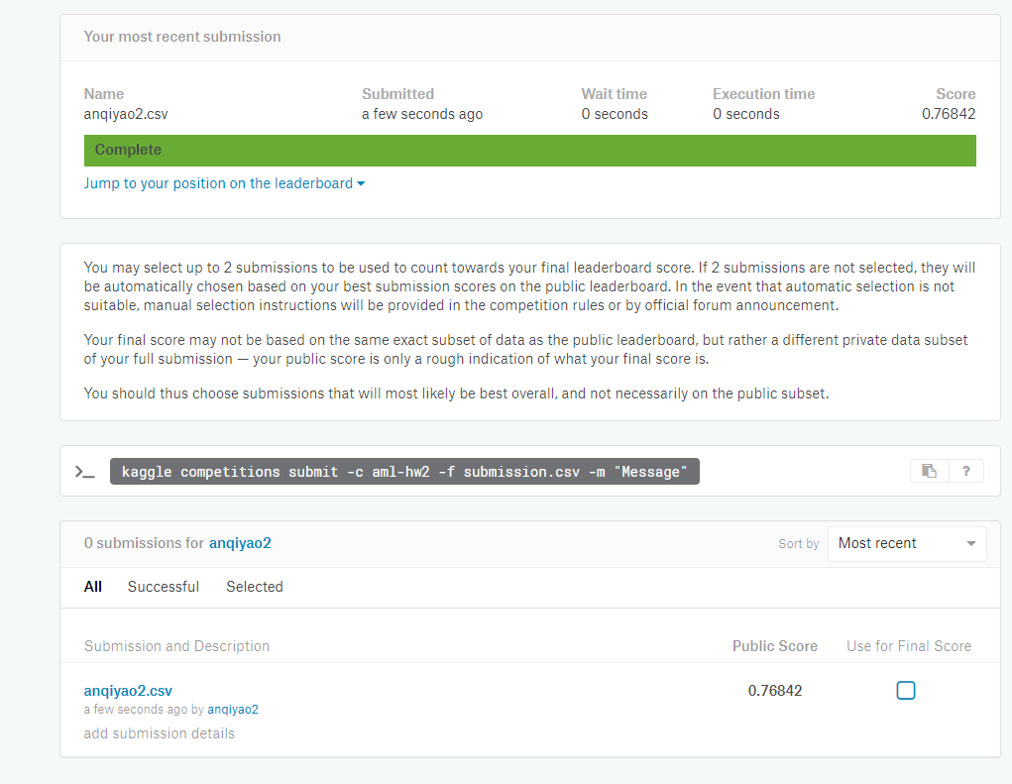

Best accuracy: 76.842%.

------1e^(-3)

------1e^(-2)

------1e^(-1)

------1

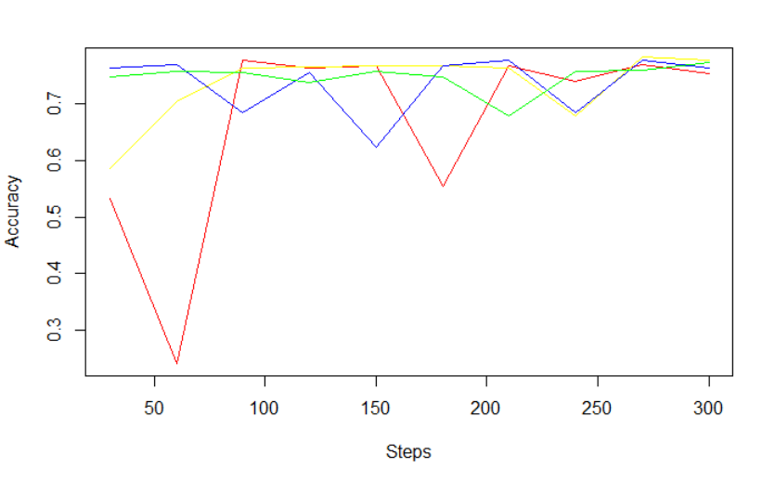

------1e^(-3)

------1e^(-2)

------1e^(-1)

------1

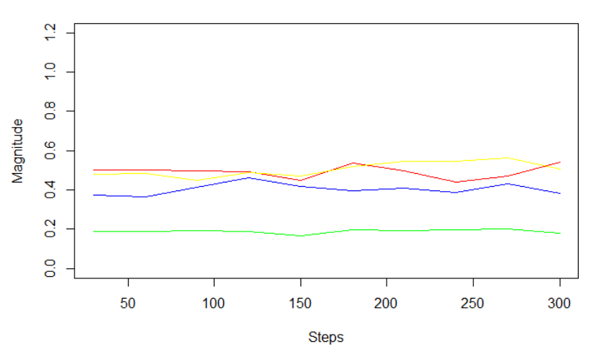

My estimate for the best regularization is 1e^(-2), because the accuracy of the test using this value is the most steady one when it reached a relatively high accuracy.

